Assignment 9: **Archive Old Files from S3 to Glacier Using AWS Lambda and Boto3**

# Create the s3 bucket with old files I have only 1 day old files in the bucket and hence will be setting up a threshold for 1day only.

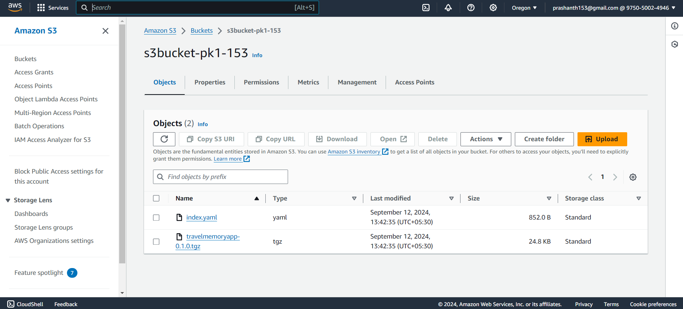

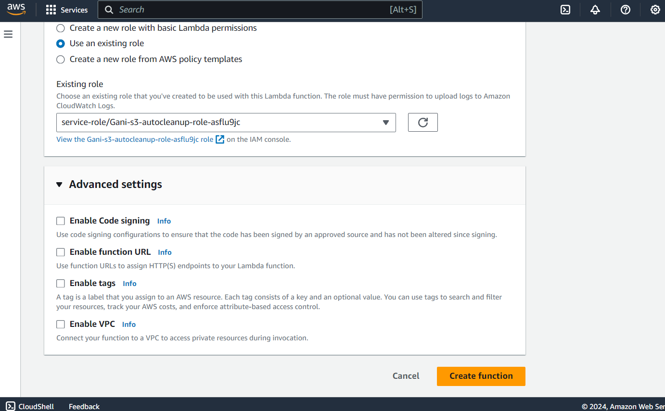

Create a lambda function for the same with threshold of 1 day only

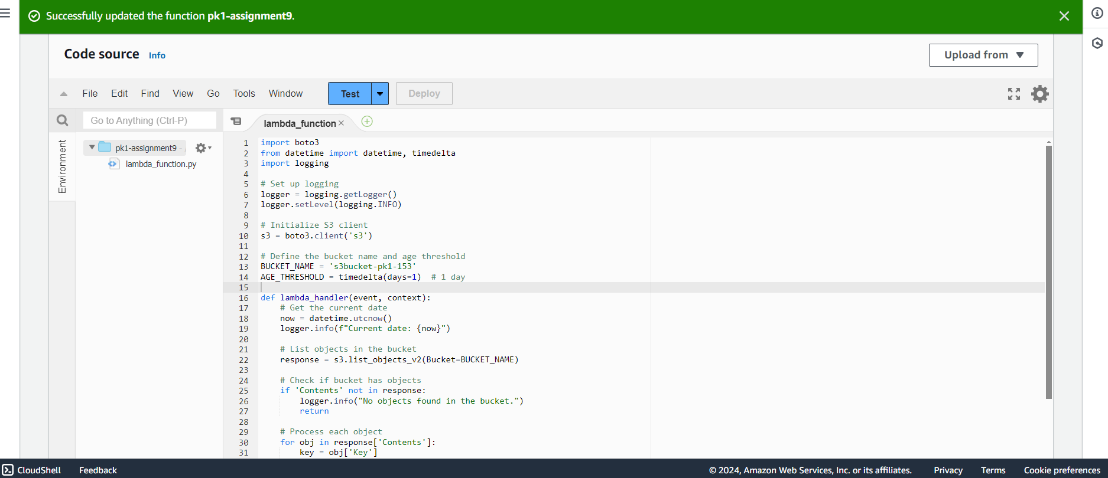

I was getting access denied error when executing this function as shown below.looks the IAM access was not available

